**AUTO MED**

**GARAGE MANAGEMENT SYSTEM**

*A project report submitted in partial fulfillment of*

*the requirements for the award of the degree of*

**Bachelor of Technology**

in

**Computer Science& Engineering**

*Submitted by*

**AKASH SINGH (19BTCSE05)**

**PREM ARPAN KHALKHO (19BTCSE27)**

**TANIA SAHANI (19BTCSE60)**

**MD FIRDOUSH MALLICK (20LBTCSE12)**

*Under the Supervision of*

**MRS. SHUSHMA RATH**

Assistant Professor



Department of Computer Science Engineering

Sambalpur University Institute of Information Technology

Burla, Odisha

Dec 2023



Department of Computer Science Engineering

Sambalpur University Institute of Information Technology

Burla, Odisha

April, 2023

**DECLARATION**

I (We) do hereby declare that the work embodied in this minor/major project report entitled “**AUTO MED GARAGE MANAGEMENT SYSTEM**” is the outcome of genuine work carried out by us under the direct supervision of Mrs. Sushma Rath, Assistant Professor Department of Computer Science Engineering and Application is submitted by us to Sambalpur University Institute of Information Technology (SUIIT), Burla for the award of the degree of Bachelor of Technology. The work is original and has not been previously formed the basis for the award of any other degree or diploma.

AKASH SINGH (19BTCSE05)

PREM ARPAN KHALKHO (19BTCSE27)

TANIA SAHANI (19BTCSE60)

MD FIRDOUSH MALLICK (20LBTCSE12)



**Sambalpur University Institute of Information Technology**

**Jyoti Vihar, Burla, Odisha, Pin: 768019**

**CERTIFICATE**

This is to certify that the project entitled **‘AUTO MED GARAGE MANAGEMENT SYSTEM ’**submitted by **Akash Singh**(**19BTCSE05), Prem Arpan Khalkho** (**19BTCSE27), Tania Sahani**(**19BTCSE60)** and **Md Firdoush Mallick** (**20LBTCSE12)** in partial fulfillment of the requirements for the award of Bachelor of Technology degree in Computer Science & Engineering at Sambalpur University Institute of Information Technology is an authentic work carried out by them under my supervision. To the best of my knowledge, the matter embodied in the thesis has not been submitted to any other University/Institute for the award of any Degree or Diploma.

**Mrs. Sushma Rath**

**Supervisor**

Assistant Professor

Department of Computer Science & Engineering

Sambalpur University Institute of Information Technology, Burla

**Counter-signed by**

**The project evaluation of the above candidates has been held on _________________**

|  |  |
| --- | --- |
| Dr. Sudarson Jena  HOD, Department of CSE&A | External Examiner |

**ACKNOWLEDGEMENTS**

We feel honored to avail ourselves for this opportunity to express our deep sense of gratitude to our guide Mrs. Sushma Rath, Department of Computer Science Engineering, Sambalpur University Institute of Information Technology, Burla, Odisha, India for her valuable inspiration, guidance, and warm encouragement throughout our research work. Her profound knowledge and timely advice were very much helpful in our research work without which our thesis could never be able to see this day. Proud to be work under her and she has given us every freedom for working in this Project.

AKASH SINGH (19BTCSE05)

PREM ARPAN KHALKHO (19BTCSE27)

TANIA SAHANI (19BTCSE60)

MD FIRDOUSH MALLICK (20LBTCSE12)

# GARAGE MCONTENTS

**Course Details Page No.**

### Title Page i

Declaration ii

Certificate iii

Acknowledgement iv

Contents v

List of figures vii

List of Abbreviations viii

Abstract ix

### Chapter 1 Introduction 1–3

|  |  |  |  |
| --- | --- | --- | --- |
|  | **1.1** | **Introduction** | **1** |
| **1.2** | **Objectives** | **2** |
| **1.3** | **Literature Review** | **3** |
| **Chapter 2** |  | **Methodology** | **5-6** |
|  | **2.1** | **Introduction (Sub-section)** | **5** |
| **2.2** | **Methods used for data collection** | **5** |
| **2.3** | **Methods to be used for system design** | **5** |
| **2.4** | **Methods to be used for system**  **Implementation** | **5** |
|  |  |  |
| **Chapter 3** |  | System design specification document. | **7-26** |
|  | **3.1**  **3.2** | **Introduction**  **Architectural and component level design** | **7**  **8** |
|  | **3.3** | **Software Context** | **9** |
|  | **3.4** | **Logical design** | **13** |
|  | **3.5** | **Database design modelling** | **15** |
| **Chapter 4** |  | **Conclusions and Future Scope** | **18-24** |
|  | 5.1 | Conclusions | 18 |
|  | 5.2 | Future scope | 18 |
|  | 5.2 | UI Screenshots | 19 |

### References 24

### 

**LIST OF FIGURES Page No**

Fig 1. Architecture 8

Fig 2. system diagram 9

Fig 3. Functions of GMS 9

Fig 4 Login flow chart. 10

Fig 7. Allocation of mechanics flow chart 12

Fig 8.Level zero DFD 13

Fig 9. E-R diagram 15

Fig 10. Screen shots of Login page 18

Fig 11 Screen shots of Register page 19

Fig 12 Screen shots of admin overview 19

Fig 13 Screen shots of Profile 20

Fig 14 Screen shots of New client 20

Fig 15 Screen shots of Inventory management 21

Fig 16 Screen shots of Invoice generator 21

Fig 17 Screen shots of Add vehicle 22

Fig 18 Screen shots of Subscriptions 22

# LIST OF ABBREVIATIONS

SDS: System Design Specification

DFD: Data Flow Diagram

NOP: Number plate

ADO: Active X Data object

ERD: Entity Relation Diagram

TBP: Total Billed Payment

**LIST OF TABLES Page No**

Table 1. Mechanic table 15

Table 2. Service data table 16

Table 3. Vehicle data table 16

# ABSTRACT

A garage management system is a software application designed to simplify and streamline the management of a garage. The system provides an easy-to-use interface that allows garage owners and managers to manage various aspects of their business, such as inventory, customer information, appointments, and billing. The system can also provide real-time monitoring of garage operations, including the status of each vehicle and the availability of mechanics.

The garage management system helps to optimize the garage's workflow and reduce the time and effort required to manage daily operations. The system can automate many tasks, such as generating invoices, scheduling appointments, and sending reminders to customers. This allows garage owners and managers to focus on providing high-quality services to their customers and improving their business.

Overall, a garage management system is a powerful tool for garage owners and managers looking to improve their operations, increase efficiency, and enhance the customer experience. With the right system in place, garage owners can achieve better results, streamline their workflows, and grow their businesses

CHAPTER-1

* 1. **INTRODUCTION**

**1.1 Introduction / Background to the Study**

In today’s developing era, the numbers of vehicles are increasing in most over the planet. So providing efficient service to every vehicle user may be a challenging task for garages in future. And vehicle users need to substitute queue for getting service. Using this application the user can locate the nearby active garages /mechanics and communicate with them to urge service in need. the aim of designing this application to facilitate the user also as service provider (i.e. garage) user are going to be benefited because they not got to move the garage which ultimately saves the time, efforts and money. On the opposite hand (for garage) number of user increases which increase the turn over and provides high return of investment. To investigate system study and analysis of the prevailing systems so on determine the

wants needed for the GMS. To design a garage Management system using open tools like Gprs to watch the situation of the garage who provide the requested services and user who want to require service, and therefore the Admin who control and monitor all activity happening between user and repair provider (i.e. garage).and display information. To implement the GMS. To

check and validate the system Manage your entire garage bookings & inventories and streamline garage operations

* Leverage regular clients to order home pickup & delivery increase loyalty
* Rollout discount offers / schemes for normal clients and ensure customer loyalty
* Customers can order car modification supported 3D interface helping them choose color, wheel type configuration & windshield replacement
* Mechanics can send automatic car service status & booking status via emails & SMS.
* Mechanics can recommend certain services or parts replacement to client supported car history
* Garage owners can assign jobs and supply rule-based access of system of varied resources of garage.

1. **Problem Statement**

Currently in garages, the workers aren't distributed properly. There isn’t any systematic approach of storing data which ends up in loss of knowledge. There are many cases where providing efficient service to every vehicle user may be a challenging task for garages. The quality at which work is completed isn't up to mark.

1. **PROPOSED SOLUTION.**

Developing a garage management system that will allow:

* + - Garage bookings & inventories and streamline garage operations.
    - Rollout discount offers.
    - Customers to order car modification supported 3D interface helping them choose color, wheel type configuration & windshield replacement.
    - Mechanics to send automatic car service status & booking status via emails & SMS.
    - Mechanics to recommend certain services or parts replacement to client supported car history.
    - Garage owners to assign jobs and supply rule-based access of system of varied resources of garage.

To monitor information a few cheap, simple structured, wireless and secure garage on the idea of a typical remote control/access. The objectives of this proposal are; to realize the aim of security, one among the aims is to implement wireless security measures to scale back the danger of the garage being breached or employed by unauthorized service providers under one system.

1. **Objective**

To investigate system study and analysis of the prevailing systems so on determine the

wants needed for the GMS. To design a garage Management system using open tools like Gprs to watch the situation of the garage who provide the requested services and user who want to require service, and therefore the Admin who control and monitor all activity happening between user and repair provider (i.e. garage).and display information. To implement the GMS. To

check and validate the system.

The main objective of a garage management system is to simplify and streamline the management of a garage, enabling owners and managers to improve the efficiency of their business operations and enhance the customer experience. Here are some specific objectives that a garage management system may aim to achieve:

1. **Automate tasks**: The system should automate tasks such as scheduling appointments, generating invoices, tracking inventory, and managing customer information, reducing the time and effort required to manage daily operations.
2. **Provide real-time insights:** The system should provide real-time insights into the status of the garage, including the availability of mechanics, the status of each vehicle, and the progress of repairs. This allows owners and managers to make informed decisions quickly and optimize their operations.
3. **Enhance customer experience:** The system should offer features such as online appointment scheduling, automated reminders, and easy billing and payment options, providing a seamless and efficient experience for customers. Improve profitability: By reducing the time and effort required to manage daily operations, the system can help to improve profitability by reducing costs and increasing revenue.
4. **Increase efficiency**: The system should optimize the garage's workflow, improving the efficiency of business operations and reducing the time it takes to complete tasks.

Overall, the objective of a garage management system is to simplify the management of a garage,enabling owners and managers to focus on providing high-quality services to their customers and growing their business.

**4.0 Literature Review**

During this era of technology everybody wants their work done very quick and on finger tip. The amount of auto goes on increasing so it's difficult task for garage shop to supply quick and efficient services to their customers. The survey regarding this web application includes operation from various sources. These sources include a number of the garages service application,

websites like Ola app, My Mazda. Ola garage is web application provide the platform through

which user is in a position to urge services which include all kinds of service. Although it's provided by Ola but it's not so popular. Serviceko is additionally an android application basically meant for vehicle service purpose, it's not fully developed and currently not in use. The GUI isn't simple hence difficult to use. IEEE papers are used for knowing the benefits and drawbacks of previously proposed system. Example In paper titled as “Automobile Service Centre Management System”: -

It may be a android based application which give facility like Notify user for service, Next service installment, EMI calculator but not provide service in out areas, no emergency service when net wont available and mechanics not go outside for service.In paper titled as” Online Management System for Automobile services”: -It may be a web based system using Angular JS, Mongo DB and Node-JS which give the feature like find nearby garage service notifications but not provide Emergency service.For clearing the concepts and algorithms included during this project.

Example Dijkstra’s algorithm for locating shortest path algorithm to schedule the available mechanics and supply the services to customer during a very efficient way. Advantages over existing system are:- (1) Emergency toll-free number to urge service just in case if user isn't accessible to internet. (2) Service to the requested location on time and in affordable budget. (3) Mechanics not related to garage also can provide services. (4) Estimated cost and time will provide to customer beforehand.

**5.0 Significance of the Study**

This project will develop a tool which will be ready to help most drivers who are having vehicles but they don’t have time to spend for vehicle service. They will use this platform to service their vehicle by trusted service provider. User are going to be ready to search the garage and request them for service. Easily select the matter and garage and take service from that. In emergency case user can use the Toll-Free number and obtain quick response. Also provide the service at location from where the request has been made whether its remote area or area under coverage, this will be

widely wont to facilitate user altogether over country since there's no solution for it. It also promotes the provider business and increase the amount of user and return of investment also.

Future scope in enlarging the system we will add another module where user are going to

be provided a rent based vehicle just in case he/she cannot wait till repairing. User can connect and inform one another wirelessly if they're passing on the brink of one another in order that user also can help each other’s in need.

Manage your entire garage bookings & inventories and streamline garage operations

* Leverage regular clients to order home pickup & delivery increase loyalty
* Rollout discount offers / schemes for normal clients and ensure customer loyalty
* Customers can order car modification supported 3D interface helping them choose colour, wheel type configuration & windshield replacement
* Mechanics can send automatic car service status & booking status via emails & SMS.
* Mechanics can recommend certain services or parts replacement to client supported car history
* Garage owners can assign jobs and supply rule based access of system of varied resources of garage.

Chapter 2

**METHODOLOGY**

2.1 INTRODUCTION

This chapter highlights the methodology to be used, methods for data collection, system design and implementation also as testing and validating the developed system. Qualitative research methods to be used for data collection, include participant observation, interviews, open ended surveys, focus groups (Drivers) and ethnographic observations.

2.2 METHODS TO BE USED FOR DATA COLLECTION

For ethnographic observation, representatives’ are going to be sent to seem for his or her own garages to request for services manually with none consultation and also participate within the repair activity and convey back feedback. Focus groups are going to be of much help since it will be able to interact with drivers who will hand over the specifications and preferences they might like within the application we develop.

2.3 METHODS TO BE USED FOR SYSTEM DESIGN

First analysis of the system are going to be wiped out order to urge the wants and data to implement the system.

From the info collected, we'll create an ERD diagram using Microsoft Office Word. it'll show the connection between the drivers and therefore the service providers(garage). The activities of the software are going to be presented using Use case diagrams, UML class diagrams and sequence diagrams to make a far better understanding of the system.

2.4 METHODS TO BE USED FOR SYSTEM IMPLEMENTATION

The software would require a interface where users can interact with the system. The interface are going to be an application Graphic interface which can be implemented using Microsoft Visual Basics.

Servers will be required so as to regulate application functionality of the software.

Databases are going to be managed using MySQL software which can store relevant information of the user and also from the service providers. Out of the database, i can retrieve information of a specific user like "how many active garages has he visited, which challenges did he/she encounter".

# CHAPTER 3

# SYSTEM DESIGN AND IMPLEMENTATION.

**3.1.** INTRODUCTION

Conceptually SDS describes how the software is to function in a general way without being involved in low-level operational details. It involves the translation of the systems specifications in the Software Requirement Specification document into technical specifications for implementation. . This document, describes the design and clear insight of the system concepts and operations of the final product. It portrays the developers understanding of the stated user requirements and a foresight of what is expected and any changes necessary before implementation.

The design then serves as a guide to the developers who shall write the code as expected by the stakeholder. The SDS discusses how the program is separated into modules, how the modules interact with each other, and how users see the program. It also looks into several design considerations, including design tradeoffs and code reusability. The designer provides for effective input to the information system by using techniques of good form and screen design.

This document will also show how users would visualize the system and detailed description of input, processes and anticipated outputs of specific sub-processes of the system. Simply SDS is a description of how the anticipated functional and non-functional system requirements in Software Requirement Specification are achieved. This includes: The different aspects of design are captured through the use of:

1. Physical design.
2. Logical Design

Due to this, there exists an urgent need to shift the mode of manual operations to automated operations to a more efficient and reliable system which shall overall improve customer experience and the performance of the garage.

* + - Development of an online Garage Management System that shall handle the garage services within the Logistics Department.
    - Setting up the system on the main server ready for deployment.
    - Training the users on how to use the new system.
    - Request for an Administrator who shall configure the new Garage Management System.

**Main Inputs**:

1. Booking Officer
2. Driver ID
3. Telephone number
4. Active garage
5. Mechanic ID
6. Amount to be paid after service

**Outputs**:

1. Enter Vehicle number
2. Add new client
3. Garage client login
4. Track garage service
   1. **3.2. ARCHITECTURAL AND COMPONENT LEVEL DESIGN**

We are starting with the software architectural design which presents the structure of data and program components of this project.

Architectural design entails definitions of components and the inter-relationships that exist between them.

Assign

mechanic

Garage login/register

Add staff/ mechanic

Delete staff/mechanic

Printing invoice

Add costumer

Edit profile

Add vehicle

Generate invoice

Inventory management

Fig 1.Architecture Block Diagram

**3.3. SOFTWARE CONTEXT**

This document generally describes the features and association between the Garage Management System and its customer.

In this section I am actually going to elaborately break down this ideological concept to clear demonstration of the same.

Consequentially, the second part of design evolves, the component-level design, In this phase, the data structures are designed and communication mechanisms allocated to each component for software development.

The environment of this system has been described below;



Clients.

Mechanics

GMS

Storage

Service

Fig 2.system diagram

These activities prove the sequential pass of the above project. This software application has be designed as we have already seen, so we need to continue further and disclose it to the targeted external entities who will make its usability relevant

Fig 3. Functions of GMS

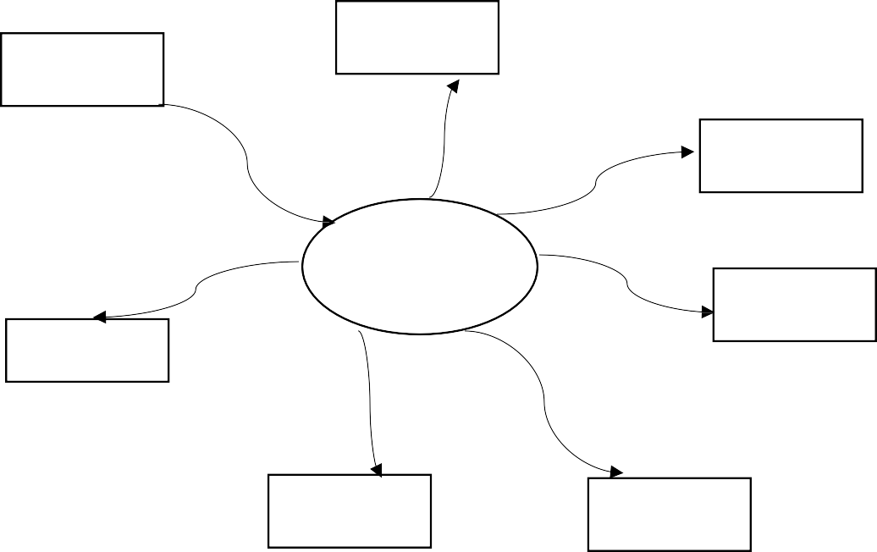

Production

Order

placement

Financial

Garage

System

Sales

Human

Resources

Services

Purchasing

**3.4 LOGICAL DESIGN**

1. Login Flowchart

This is a graphical step by step representation of how a user logs into the system.

User is registered

**Start**

Admin loginID and password

Check

login ID password

Invalid login

password

Login to the

system succesfully

Set user level and

permission

End

Access the internal

functionalities according to permission

Fig 5.Login flow hart

1. Service Booking Flow Chart

User login

Select add service



Enter vehicle details

Are client

details correct

correct service

details

print receipt

Log out

submit service report

Fig 6. service booking flow chart

# Allocation of Mechanic Flow Chart

User login



Check available Mechanics

Are

mechanics available

Wait for

mechanics to be available

print job ticket

Receive service bookings

Log out

respond to booking officer

Fig 7. allocation of Mechanic

3.5 DATA FLOW DIAGRAM:

Level zero DFD(Context Diagram):

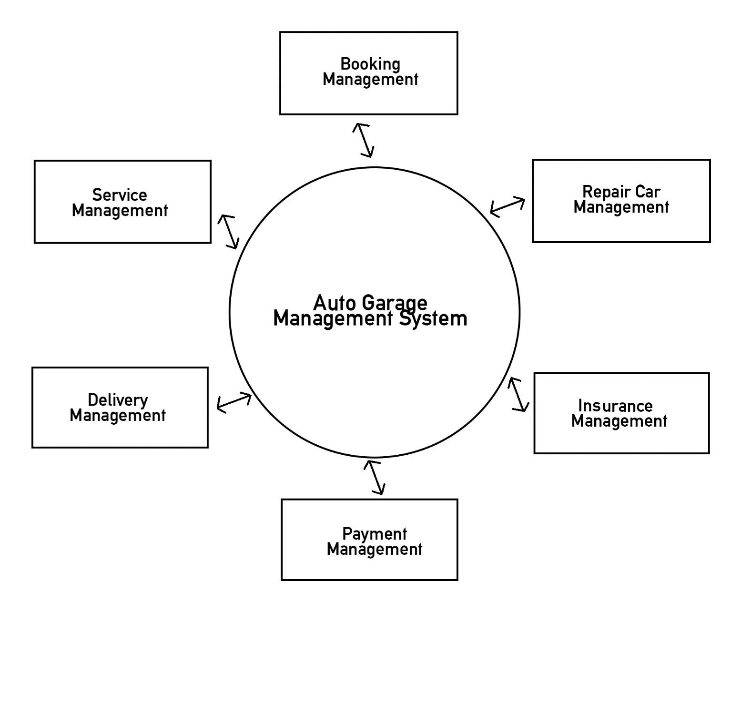

Fig 8. Level zero DFD

Fig 9.Level one DFD

Fig 10.level two DFD

Use case Diagram

AUTO GARAGE MANAGEMENT SYSTEM

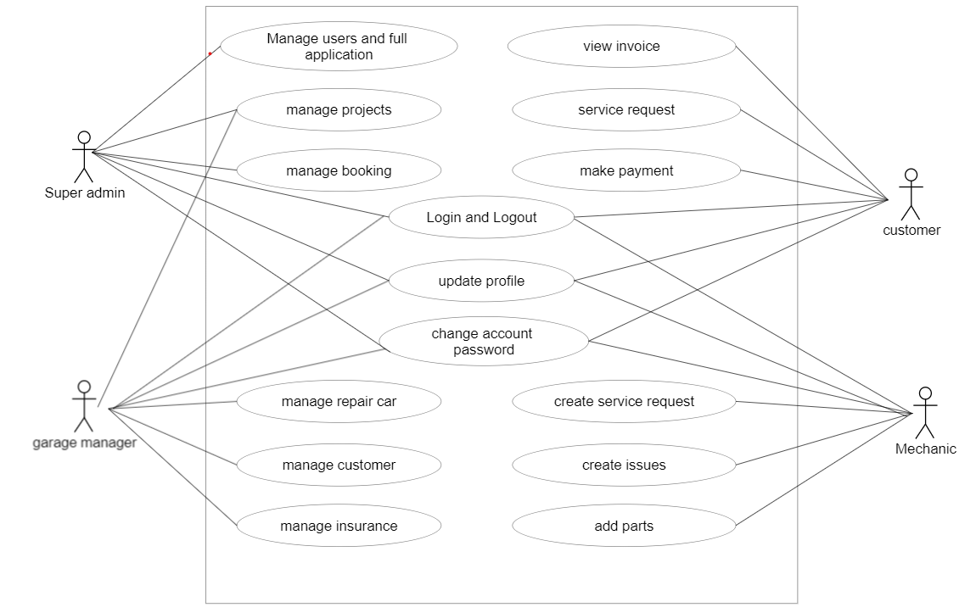

Fig 9. Use Case Diagram

**3.6. DATABASE DESIGN MODELLING**

All data is accorded a database model. The database management system manages the data well. A data model identifies things of importance to an organization, properties of that organization and how the organization is related to one another.

The model provides accurate pictures of the information needs of the organization. The techniques used in data modeling are:

* Data Normalization
* Data Dictionary

All the entities, attributes, relationships between different juice models is organized and described evenly to allow for a timely database design.

Database Description

The GMS, has quite a number of employees, it has different varieties of services offered, stakeholders of course its potential clients, , order (placement). All these definitely fall under the entity classes.

These entities has attribute allocation, and consequently, they possess some sort of relationships amongst each other.

Normalization, in this case can be pretty vital, to allow for non-redundancy of records, and enhance proper storage of records in the physical model of the database.

* + 1. **5**.Entity-Relation Diagram

ERD show how the entities identified in this section are mapped into tables of the database for the Garage Management system software. This design simply highlights the association between one entity and another, through it; users are in a good position to manipulate it during database programming, this facilitates the development of database design.

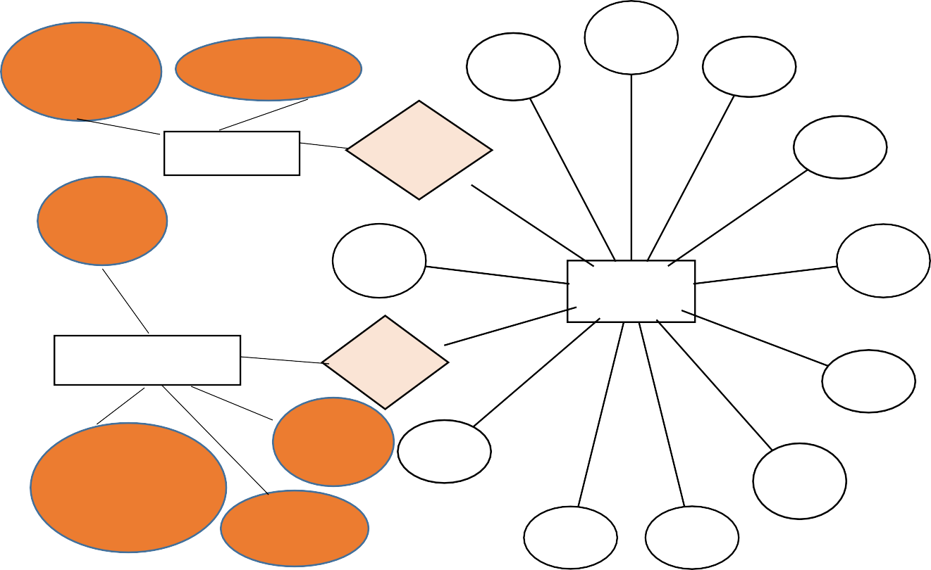

Service No

Mechanic

ID

Department

Driver ID

Category

**MECHANIC**

Assigned To

Sender

Name

Vehicle

ID

Driver

Name

Sender

Phone No

**SERVICE**

**VEHICLE/OWNER**

Books

Service

Sender ID

NO

Number

Plate Registration

Driver

Name

Garage

Receiver

Name

Garage

Receiver ID

Receiver

Phone NO

Fig 10.ER diagram

# THE DATABASE SCHEMA

Below is derived from the Entity-relation diagram above

|  |  |  |
| --- | --- | --- |
| **MECHANIC DATA ENTRY** | | |
| *DATE ITEM* | *TYPE* | *COMMENT* |
| Mechanic ID | Integer | Used as primary Key |
| Department | String | Select |

Table 1. Mechanic table

|  |  |  |
| --- | --- | --- |
| **SERVICE DATA ENTRY** | | |
| *DATE ITEM* | *TYPE* | *COMMENT* |
| Service No | Number | Used as primary Key |
| Category | Text |  |
| Sender Name | Text |  |
| Sender Phone NO | Number |  |
| Sender ID | Number |  |
| Receiver Name | Text |  |
| Receiver Phone NO | Number |  |
| Receiver ID | Number |  |
| Garage | Text |  |
| Driver Name | Text |  |
| Driver ID | Number |  |

Table 2. Service data table

|  |  |  |
| --- | --- | --- |
| **VEHICLE DATA ENTRY** | | |
| *DATE ITEM* | *TYPE* | *COMENT* |
| Vehicle ID | Integer |  |
| Number Plate Registration | Character | Used as primary Key |
| Garage | Text |  |
| Driver Name | Text |  |

**T**able 3. vehicle data table

# CHAPTER 4

# CONCLUSION

# In conclusion, a garage management system is a valuable tool for garage owners and managers looking to improve the efficiency of their business operations and enhance the customer experience. By automating tasks, providing real-time insights, and offering features such as online appointment scheduling and easy billing and payment options, the system simplifies the management of a garage and helps to optimize workflow. This, in turn, can lead to increased profitability and growth of the business.

# Implementing a garage management system requires careful planning, including identifying the specific needs of the business, selecting the appropriate software, and training staff to use the system effectively. However, the benefits of a garage management system are numerous, including improved efficiency, increased customer satisfaction, and ultimately, increased revenue.

# In today's fast-paced business environment, a garage management system can provide a competitive advantage, allowing garage owners and managers to focus on providing high-quality services to their customers while optimizing their operations. Overall, a garage management system is an essential investment for any garage looking to streamline their business operations, improve the customer experience, and achieve long-term success.

# FUTURE SCOPE

# 

# The future scope of garage management systems is promising, with several advancements expected in the coming years. Here are some potential areas for future development:

# Integration with IoT: With the growing popularity of the Internet of Things (IoT), garage management systems may be integrated with IoT devices, allowing garage owners and managers to monitor and control various aspects of their garage remotely. This could include monitoring the status of vehicles and equipment, tracking energy usage, and optimizing workflow.

# Predictive maintenance: Using machine learning algorithms and predictive analytics, garage management systems could provide insights into potential maintenance issues before they occur. This would allow garage owners and managers to proactively address problems, reducing downtime and improving customer satisfaction.

# Mobile optimization: With the increasing use of mobile devices, garage management systems could be optimized for mobile use, allowing customers to schedule appointments, receive updates on vehicle repairs, and make payments from their mobile devices.

# Integration with other software: Garage management systems may be integrated with other software, such as accounting software, marketing software, and CRM software, to provide a comprehensive solution for managing a garage.

# 

# Automated billing and payment: Garage management systems could automate the billing and payment process, including sending invoices, processing payments, and generating financial reports, reducing the time and effort required to manage financial operations.

# Overall, the future of garage management systems is promising, with the potential to enhance the efficiency and profitability of garages while improving the customer experience. By incorporating new technologies and features, garage management systems can continue to evolve and meet the changing needs of the industry

# USER INTERFACE(UI):

# 

# Fig 11. Login page

# 

# Fig 12. Register page

# 

# Fig 13.Screenshot admin overview

# 

# Fig 14. Profile

# 

# Fig 15. New client

# Fig 16.inventory management

# 

# Fig 17.Invoice generator

# 

# Fig 18.Add vehicle

# 

# Fig 19.Subscriptions

# REFERENCES

1. “Hanamant B. Sale , Dharmendra Bari , TanayDalvi , Yash Pandey”, “Online Management System for Automobile Services”, International Journal of Engineering Science and Computing (IJESC), Volume 8 Issue No.02, March-2018.
2. “Prof. Shilpa Chavan Saket Adhav, Rushikesh Gujar, Mayur Jadhav, Tushar Limbore”,“Automobile Service Center Management System”, International Journal of Scientific and Research Publications, Volume 4, Issue 3, March 2014.
3. "Garage Management System" by Dhaval Patel, International Journal of Advance Research, Ideas and Innovations in Technology (2017).
4. "Design and Development of Garage Management System" by P. Srinivasa Rao, S. Sreekanth Reddy, and B. Suresh, International Journal of Innovative Research in Science, Engineering and Technology (2016).